🚀 **SQL Challenge: Identify Users Who Added to Cart After a Page View on the Same Day**

🔎 Perfect for SQL interview prep or building analytical thinking!

Recently, I worked on an interesting SQL scenario simulating **e-commerce user behavior tracking**:

🎯 **Problem Statement:**

Given a table UserActivity with:

* UserID
* ActionType (Page_View, Add_to_Cart, Purchase)
* ActionTimestamp

✅ The task: Find **UserIDs of customers who performed an 'Add_to_Cart' action strictly *after* a 'Page_View' on the same day**. Each UserID should appear only once.

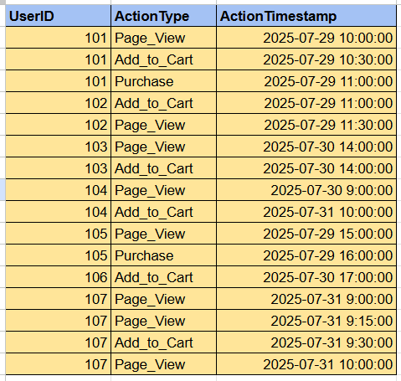

🛠️ **Approach:**  
1️ **Extract Page_View events** into a CTE.  
2️ **Extract Add_to_Cart events** into another CTE.  
3️ **Join** them by UserID, ensuring both actions occurred **on the same day** (using date formatting on ActionTimestamp).  
4️ Filter where Add_to_Cart happened **strictly after** Page_View.  
5️ Select **distinct UserIDs** to avoid duplicates.

```

with Page_View_Events as (

select UserID, ActionType, ActionTimestamp from UserActivity where ActionType = 'Page_View'

),

Add_to_Cart as

(

select UserID, ActionType, ActionTimestamp from UserActivity where ActionType = 'Add_to_Cart'

)

select distinct p.UserID from Page_View_Events p join Add_to_Cart a on p.UserID = a.UserID and date_format(p.ActionTimestamp, '%d-%m-%y') = date_format(a.ActionTimestamp, '%d-%m-%y')

where a.ActionTimestamp > p.ActionTimestamp;

```

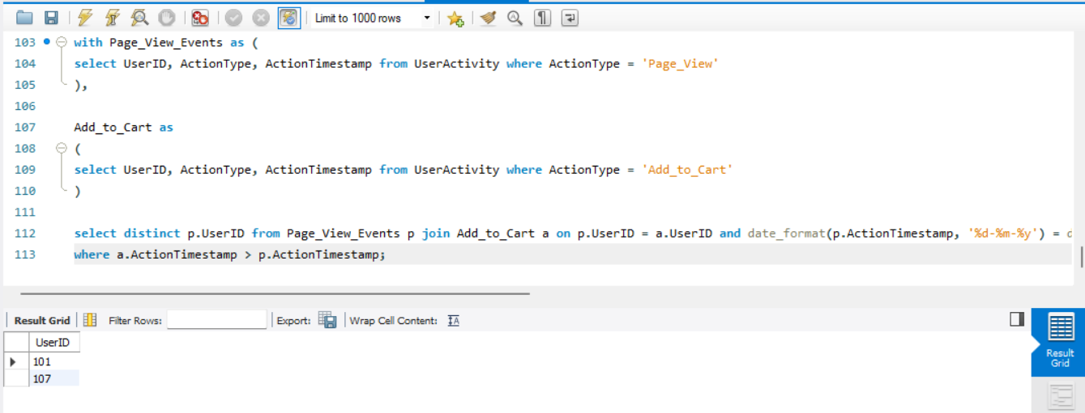

🧠 **Key Takeaways:**   
✅ Mastering window functions and date manipulation is crucial in real-world SQL analytics.  
✅ Challenges like these teach **temporal event analysis**, a critical skill for BI, data science, and engineering roles.  
✅ This logic can directly power features like **funnel analysis** in e-commerce!

💬 Have you faced similar SQL challenges? Share your approach below!  
#SQL #SQLQueries #DataAnalytics #Ecommerce #PageView #AddToCart #LearningByDoing #SQLInterview #DataEngineering #PratikBawane #LinkedInLearning